Updated in-app survey training content

Landscape

Forest size
“This question focuses on the forest surrounding your plot (this might be different to the size of your MU if your MU is patchy or contains other landcover types such as farmland or grassland, or if the area of forest is larger than the boundaries of your MU). Small patches may still have significant conservation value if they are very close to larger patches, therefore choose the largest size class for the patch you are within, or for a patch that is within 500m of the patch you are in, whichever is larger ”.
Habitats
“Tick any of the important habitat features you can see from your plot, or “none of these”.
Trees
>80cm – “The number of very large trees (over 80cm in diameter). A person’s forearm from the elbow to the fingertips is about 40cm long. Count the number of trees along the plot with trunks that are over two forearm lengths wide. If a tree has large buttress roots, look at the width above these roots.”
[I think it is better to measure using to forearm lengths rather than a whole arm plus a hand which isn’t so neat- change the diagram in the icon accordingly.]
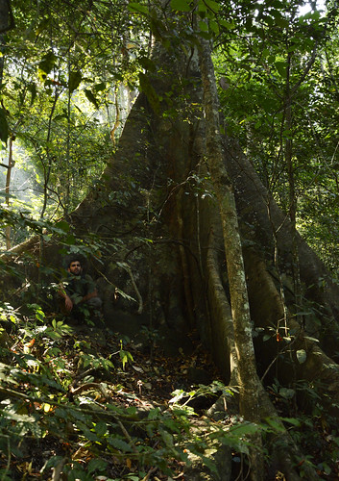
> 40cm – “The number of large trees (over 40cm in diameter). Count the number of trees with a trunk that is wider than one forearm length (including those in larger size classes). If a tree has large buttress roots, look at the width above these roots”
>20 cm- “The number of medium trees (over 20cm in diameter). A person’s hand is about 10cm wide at the palm. What is the number of trees with trunks over two hand widths (including those in larger size classes)”
[add photo of a tree with two hands next to it]

>10 cm- “The number of small trees (over 10cm in diameter). A person’s hand is about 10cm wide at the palm. What is the number of trees with trunks over one hand width (including those in larger size classes)”
[add photo with hand next to it]
1-10cm “Are there lots of saplings (more than 100) along the plot? Saplings are young trees with a trunk between 1 and 10cm in diameter- that’s more than the width of your finger but less than the width of your hand”.
[add photo with finger and hand next to it]

Dead trees “Make sure you look up into the canopy – sometimes large standing tree trunks are actually dead trees”
Biodiversity- Plants
Fruit “Count the number of trees or climbers which currently have figs or other fleshy fruits which might be important food sources for animals near your plot (don’t count the number of individual fruits!)”. Check for fruits on the ground, as sometimes this is an easier way to spot them than high in the canopy.
[photos of figs, mangos, jackfruit etc]
Moss “Count the number of trees with trunks that are heavily covered in mosses (over at least one third of the trunk is covered)”
[photo of a mossy tree]
Lianas “Estimate the number of lianas and vines with stems larger than 5cm in diameter.”
[photo]
Orchids “Count the number of trees which support other epiphytic plants including ferns and orchids. Epiphytes are plants which grow on trees and not from the ground (don’t count the number of individual plants growing on the trees!)
[photo]
Biodiversity- animals
Nests – “Tick if you find any nests, burrows or nesting holes that could be made or used by mammals, birds and reptiles. Don’t forget to tick “none of these” if you can’t see any from your plot.”
[photo examples]
Foraging- “Signs of foraging or other activity could include part eaten fruit or animal carcasses, wallows, scratching posts etc.
[photos of examples]
Mammals- “Mammals are quite difficult to find even in very good forest, but if you see or hear one or more wild mammals while on your plot walk, tick this box- take a photo if you can but only if it is safe to do so”

Earth worms- “Look on the forest floor, and check under leaf litter for earth worm casts and cicada chimneys.”
[add photos and/ or diagrams of what these look like]

Leeches “choose the tick box if you see one or more leeches on your plot. Leeches will be on the forest floor or on low vegetation”
[photo]

Threats
Visibility- “If you can see less than 10m into the forest at eye level for large stretches of your plot because of thick undergrowth choose the tick option. If you can see more than 10m for most of the plot because there is not much vegetation in the way, choose the cross.”
[photo]

Large grassy areas- “If there are one or more open grassy areas along your plot (not including those caused by a natural tree fall) choose the tick option.”
[I’ve asked for this diagram to be changed several times, as illustrated in my initial app redesign document (see below)- i.e. with trees around the grassy area so it doesn’t look like it is a natural plain.]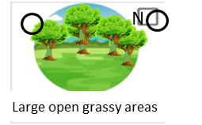
[photo]
Tangled masses- “Choose the tick option if there are thick swathes of vines, that look like they are strangling trees, similar to the photo below (choose the cross option if there are only a few vines or lianas present)”
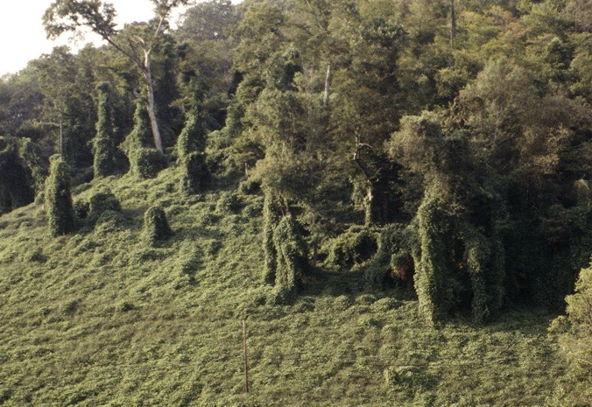(not creative commons- we will get some photos taken by SEARRP’s staff once they are released from lockdown)

For the last two questions they are pretty self-explanatory- we may add a few photos to illustrate what these might look like in real life.

