Documentation of FIA Project Server Side
Prepared by Barefoot Lightning Ltd. UK.
22nd April, 2023
FIA – Project Introduction
Requirements
Tropical forest ecosystems are at risk of clearance for agricultural expansion and the palm oil industry is a key driver of deforestation across the tropics. To tackle this, the Roundtable on Sustainable Palm Oil (RSPO) certification standard requires oil palm growers to set aside and manage forests within their plantations. However, these sites are often managed by companies or smallholder groups that have limited access to knowledge of forest ecology or conservation. A lack of guidance about how to monitor and manage these areas means that the full conservation potential of these policies is not currently being realized.

Assessing and monitoring the quality of forest set asides is vital for applying appropriate management practices. However, existing methods for forest assessment are time-consuming, expensive and/ or require specialist expertise. As a result, monitoring of these forests is often done poorly, inconsistently, or not at all. Small farmers may be prohibited entirely from participating in certification schemes because of the burdens of management and monitoring. Thus, oil palm growers require a robust, inexpensive, quick and easy tool for monitoring forest quality and restoration efforts. They also need the knowledge to effectively interpret and act on the results of monitoring. The RSPO will benefit from a consistent, standardized method which will enable better auditing and assessment of the impact of certification on forest conservation.

NERC-funded research has huge potential to inform the development of simplified conservation tools. As part of PI JL's NERC Knowledge Exchange fellowship we used data on biodiversity and ecosystem functioning to develop and test a Forest Integrity Assessment (FIA) survey tool for SE Asian forest. Relying only on yes-no answers, with no need for expensive equipment, measurements or taxonomic identification, the survey results of volunteers ranging from postdoctoral researchers to plantation managers revealed strong correlations with a variety of scientific forest quality metrics.

This project aims to convert the tool from its current paper form to a dynamic smartphone application. The benefits of this include 1) in-app training to improve accuracy, 2) the ability to quickly digitally record and store survey results, 3) improved portability and efficiency in the field, 4) integrated GPS mapping, 5) automated analysis of results 5) in-built decision support to enable adaptive management. Digitalization will provide opportunities to build in further capabilities such as remote sensed information, machine learning, long-term storage, archiving and the ability to expand the product for different regions and sectors. These benefits will transform the usability of the FIA tool, enabling widespread uptake and delivering high quality environmental management.

The requirement for this project is for the development of an Android based mobile App to be used as a Forest Integrity Assessment Tool for the forest set-asides, initially focusing on the palm oil sector in SE Asia and later in other areas.

Specific objectives

Objective 1: Provide a user-friendly digital survey tool for monitoring forest set-asides that meets end-user requirements

Output 1: A prototype smartphone application for conducting surveys in the field, with built-in training and user support, and user-friendly interfaces.

Objective 2: Provide evidence-based decision-support that meets end-user requirements to enable translation of monitoring results to management actions for improving forest quality and conservation.

Output 2: A decision-support web dashboard with trend analysis and management recommendations.

Service description
The As discussed there may be some minor alterations to the project scope during the course of the more detailed design work undertaken in conjunction with your team and the user organizations in Malaysia.

The App will be developed for Android phones as the most widely adopted operating system in the target markets (Indonesia/Malaysia) using Android Studio to develop the Apps.

The back-end databases we will use the highly scalable open-source MySQL database / language with phpMyAdmin for GUI development and NetBeans and Eclipse for PHP programming.

The application will be set-up to function off-line with training content embedded in the application so that users do not need network connectivity to either learn how to use the application or to collect data. Data will be synched to the server when the phone is connected to WIFI or an internet network connection.

The App will collect GPS location data for mapping where forest/mountain cover allow the App to receive GPS signals.

We will also build a management dashboard to allow surveys to be coordinated and managed remotely as well as to capture and review data from the field.

Decision support tools to support remediation and forest improvement plans will be developed to work both in the phone with the user (so small-holders and field workers can review these whilst in the forest) as well as for management resources on the dashboard to allow for longer-term planning and strategies to be developed.

The app will be designed to be flexible to allow for continuous development and expansion of capabilities to include surveys for different regions and forest types, analysis, incorporation of additional systems and data, to respond to user feedback etc. The application will have a visually engaging and user-friendly interface, and English and Bahasa language options.
In-app training support in the form of text, image, video/ animated instructions and pop-out information boxes that can be accessed while the survey is being conducted will also be added with the support of Oxford University team to provide training content.
In-app training support in the form of text, image, video/ animated instructions and pop-out information boxes that can be accessed while the survey is being conducted will also be added with the support of Oxford University team to provide training content.
In addition to the deliverables listed training support will be provided as well as co-design interventions at workshops and meetings as per the project schedule.
App updates, bug fixes and support will continue for the duration of the project (until 31st March 2021) and data will be hosted for 18 months post completion of the project to allow time to develop sustainable models for delivery of the service. Support will be provided for handover of databases and anything else required to run the app and web portal in the event of transfer to another service provider before the end of the 18-month period.

The source code will be provided so that the development can be continued independently. Detailed documentation and training can be provided for an additional fee if required.
There are a number of areas where the supplier will require support from The University of Oxford and project partners, especially around the supply of content and scripts for the training and also in the development of the rules to provide the assessment results.
If the Riparian Assessment is added technical input from University of Oxford will be required similar to that provided through the well-developed and defined FIA Survey Questionnaires and Guidance Documentation.

Table of Contents

- Libraries………………………………………………………………………… 5
  - Bootstrap 5
  - DataTables 5
  - table2excel 5
  - Google Charts 5
  - Chartjs 5
  - Leaflet 6
  - Jspdf 6
- Login………….……………………………………………………………………. 7
- Survey Data……………………………………………………………………… 8
- Global View Dashboard…….……………………………………………… 10
- Group View Dashboard……………………..……………………………… 11
- Mu View Dashboard…………………………………………….…………… 13
- Focal Species….………………………………………………………………… 15
- Habitat/Threat/Hazard….………………………………………………… 16
- Map………….……………………………………………………………………… 17
- Image………….…………………………………………………………………… 19
- Setting……………………………………………………………………………… 21
- Focal Species Control………..……………………………………………… 22
- Management Unit………………..…………………………………………… 23
- User Training…………………………………………………………………… 24

1. Libraries

This repository also contains additional JavaScript / CSS common libraries in FIA Project. The primary purpose of the library set is to provide supplemental functionality for GUI and Feature.
Key features: -
- Charts:
  - Box and Whisker
  - Line Chart
  - Bar Graph
- Export Data:
  - As Excel
  - As PDF
  - As Image
- Map
- KML Files
- Project Language
Bootstrap

This library implements responsive web design a reality. It makes it possible for a web page or app to detect the visitor's screen size and orientation and automatically adapt the display accordingly.

DataTables
This library implements to create HTML tables with functionality like searching, sorting and pagination. It is mobile friendly library which can adapt to the viewport size.

Table2excel
This library implements to download table contents into the excel with same format.

Google Charts
This library implements to creates graphical charts from user-supplied information. The user supplies data and a formatting specification expressed in JavaScript embedded in a Web page; in response the service sends an image of the chart.

Chartjs
This library implements to create Box and Whisker chart.

Leaflet
This library is designed with simplicity, performance and usability in mind. It works efficiently across all major desktop and mobile platforms, can be extended with lots of plugins, has a beautiful, easy to use and well - documented API and a simple, readable source code.

Jspdf
This library is an open-source library for generating PDF documents using JavaScript. It uses various functions to create various elements of PDF pages.

2. Login

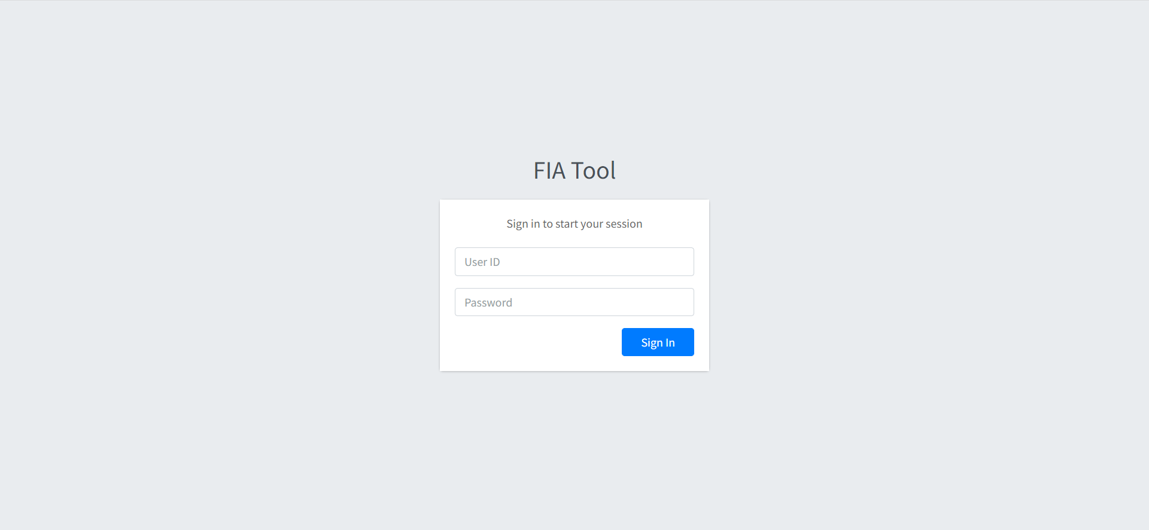

Figure 1: FIA Login Page

3. Survey Data
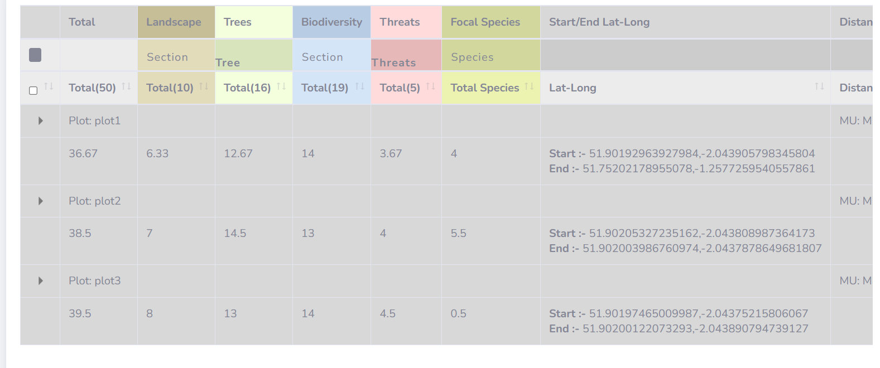
Figure 1: Selected Group/ Mu Output in the Table

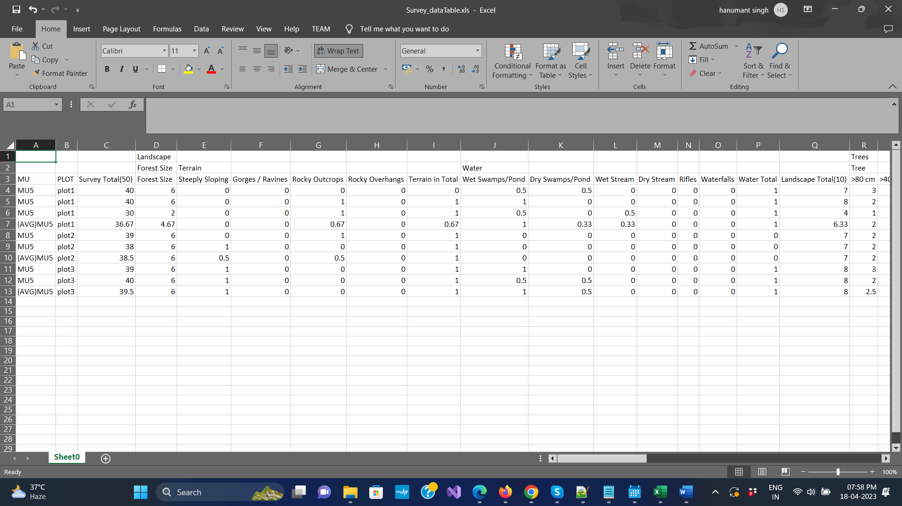
Figure 2: Selected Group/ Mu Output after Export

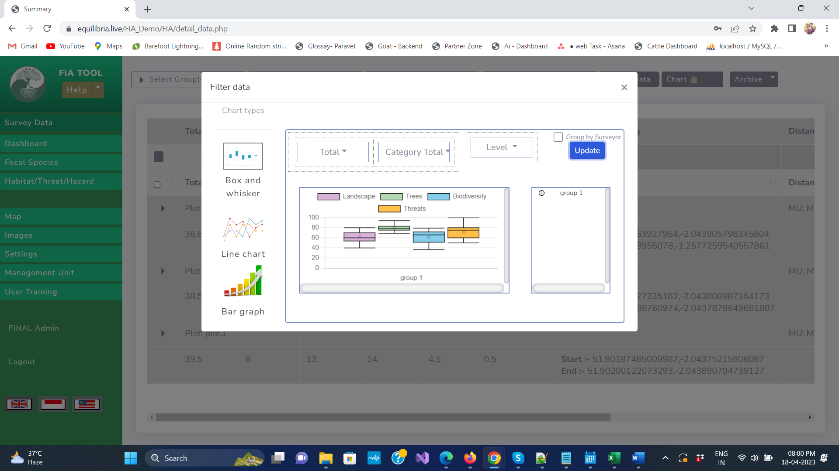
Figure 3: Chart Output

4. Global View Dashboard
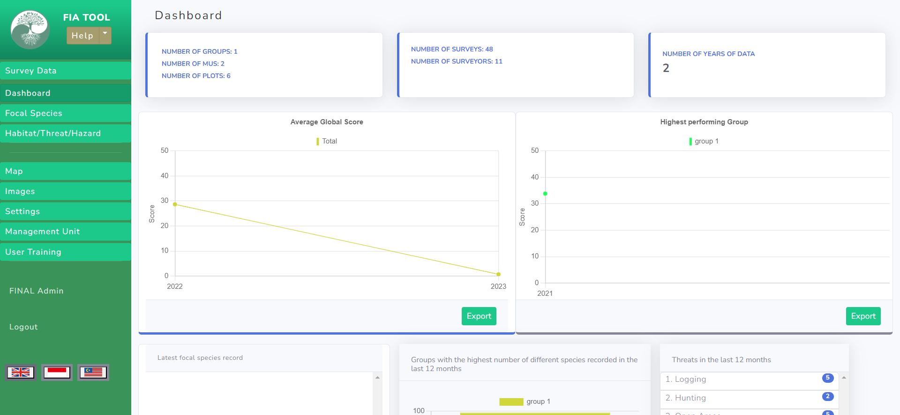

Figure 1: Global View Dashboard with showing Average score of group and highest performing group

5. Group View Dashboard
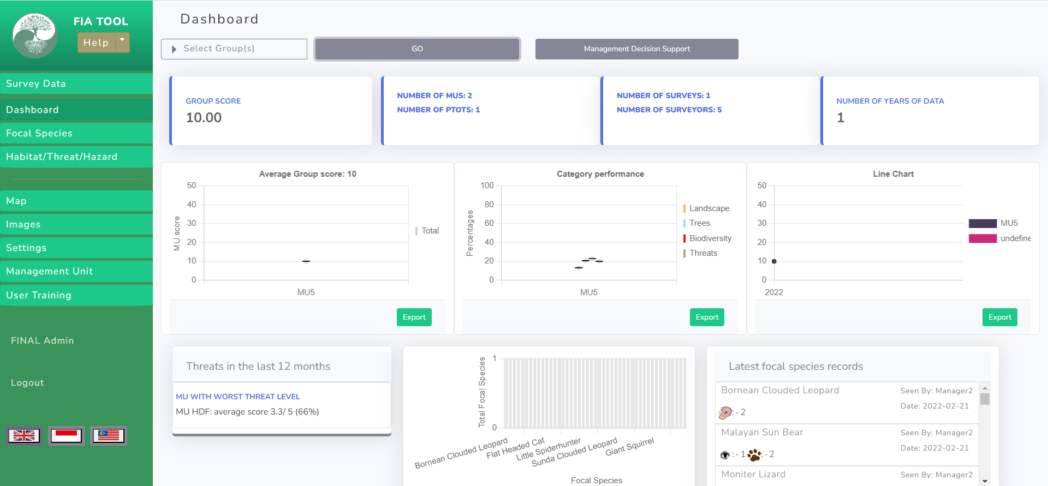

Figure 1: Group View Dashboard with selected group score.
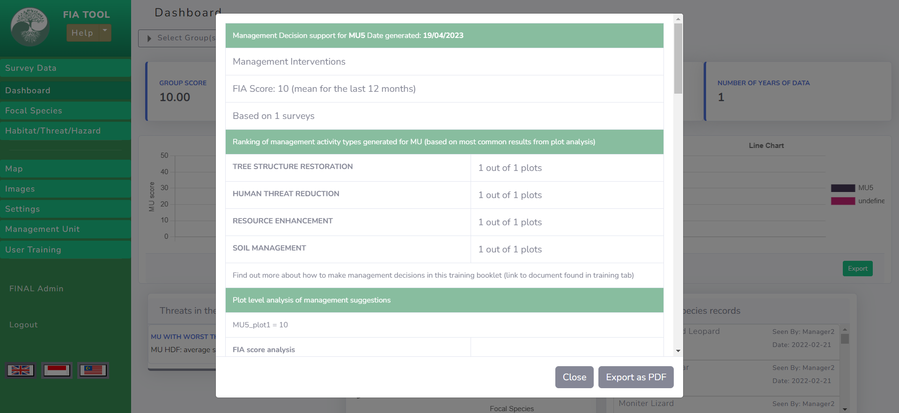

Figure 2: Selected group management decision support.
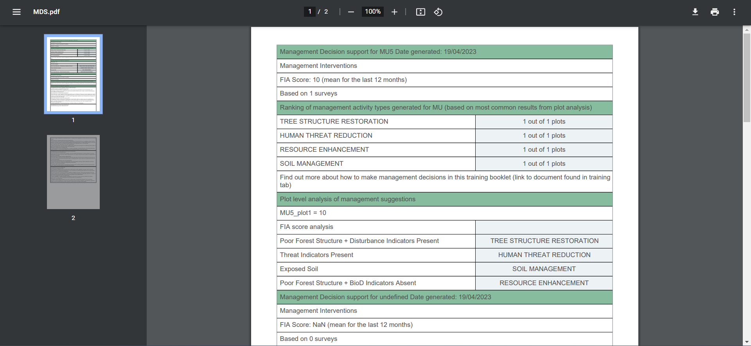

Figure 3: Selected group management decision support exported PDF.
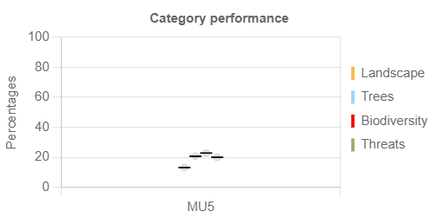

Figure 4: Selected group category performance exported Image.

6. Mu View Dashboard
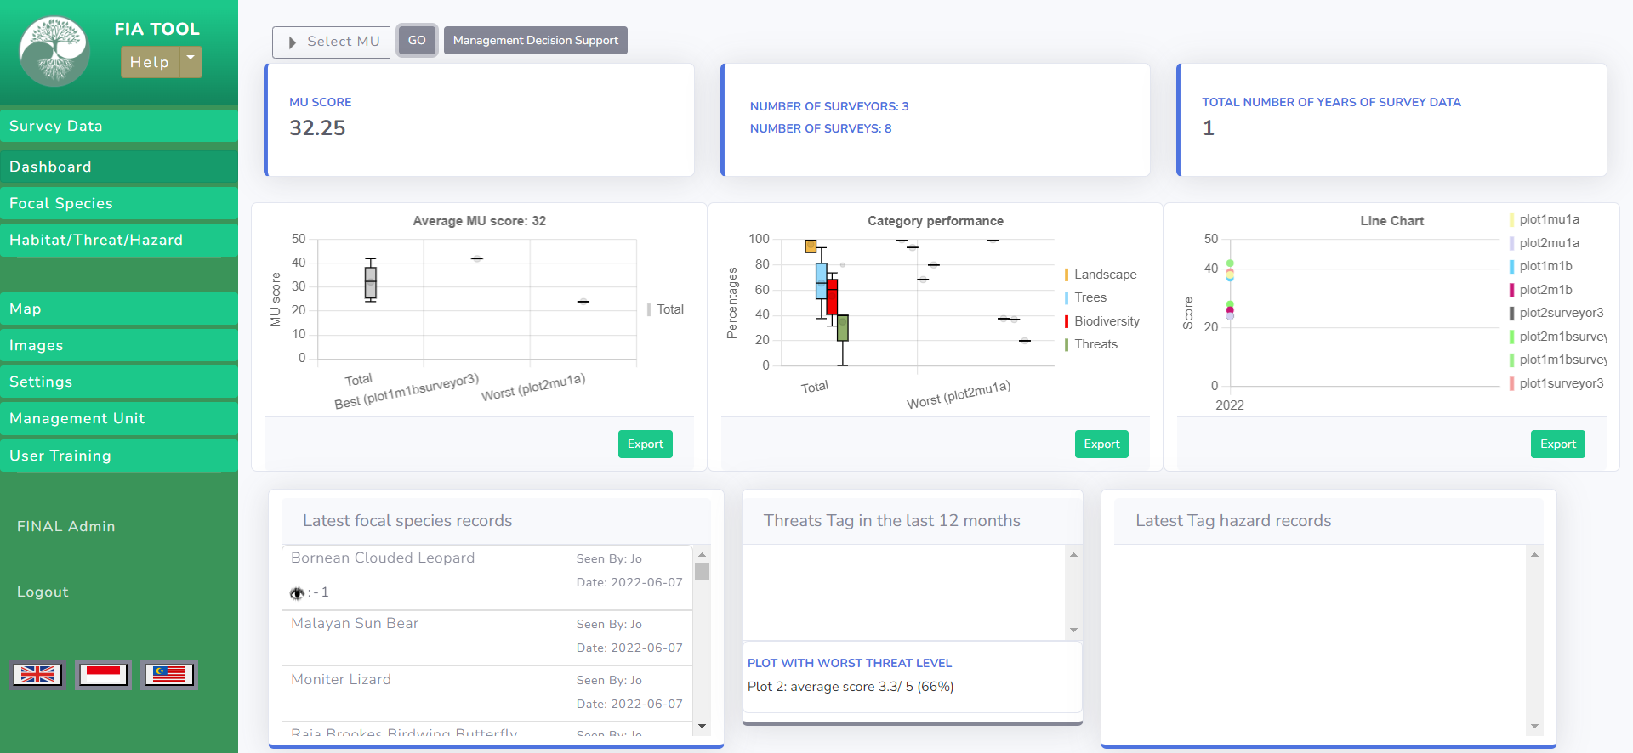

Figure 1: Mu View Dashboard with selected mu score.
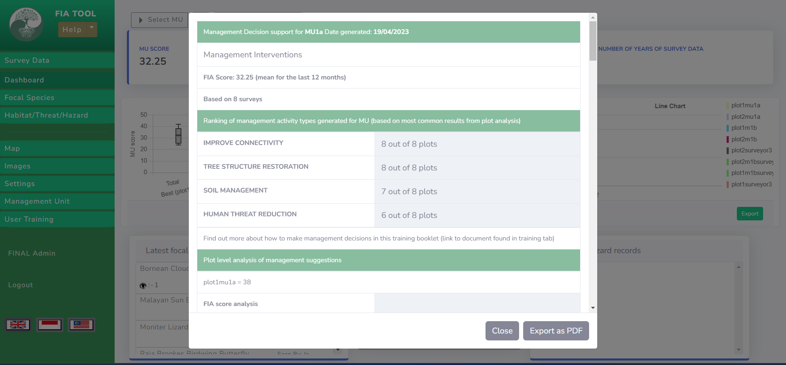

Figure 2: Selected mu management decision support.
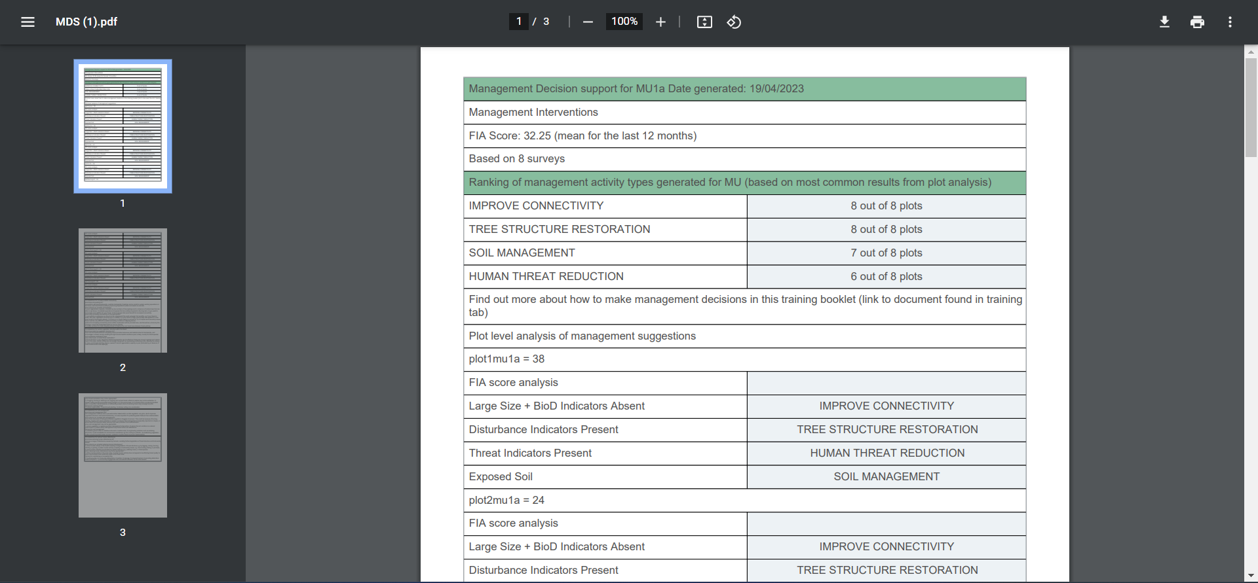

Figure 3: Selected mu management decision support exported PDF.
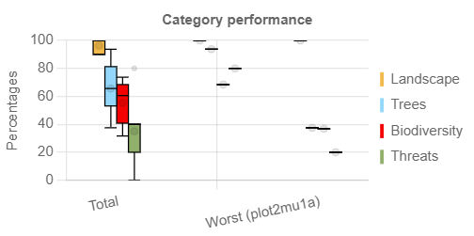

Figure 4: Selected mu category performance exported Image.

7. Focal Species
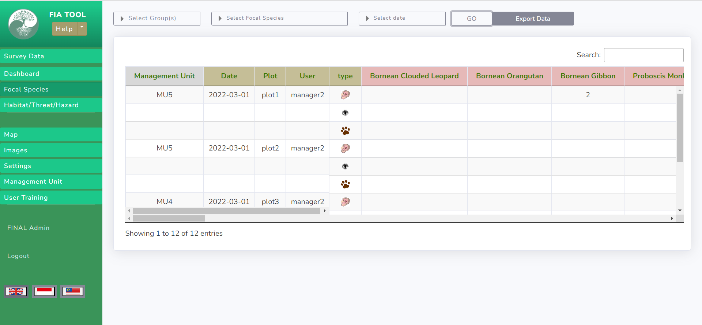

Figure 1: Selected Mu Focal Species records.
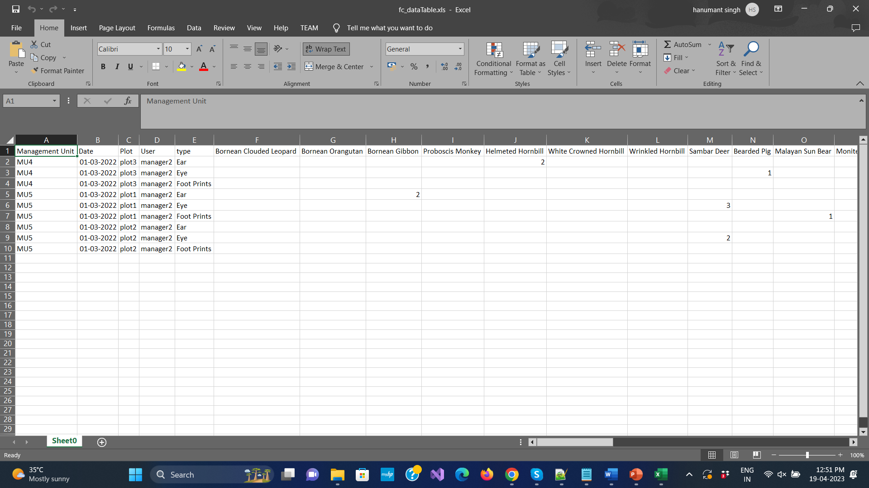

Figure 2: Selected Mu Focal Species records export file.

8. Habitat/ Threat/ Hazard
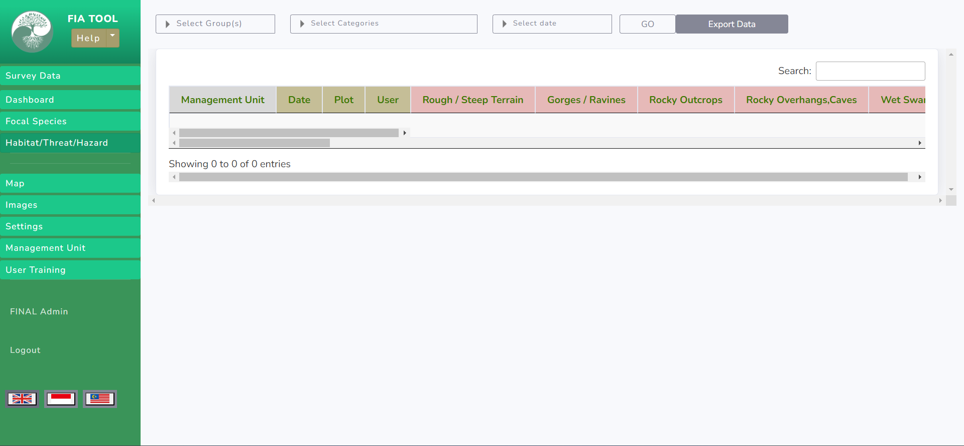

Figure 1: Habitat/Threat/Hazard records.

9. Map
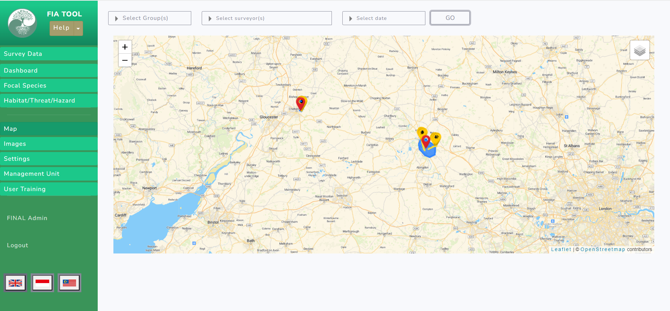

Figure 1: Selected Mus boundaries and track records with marker.
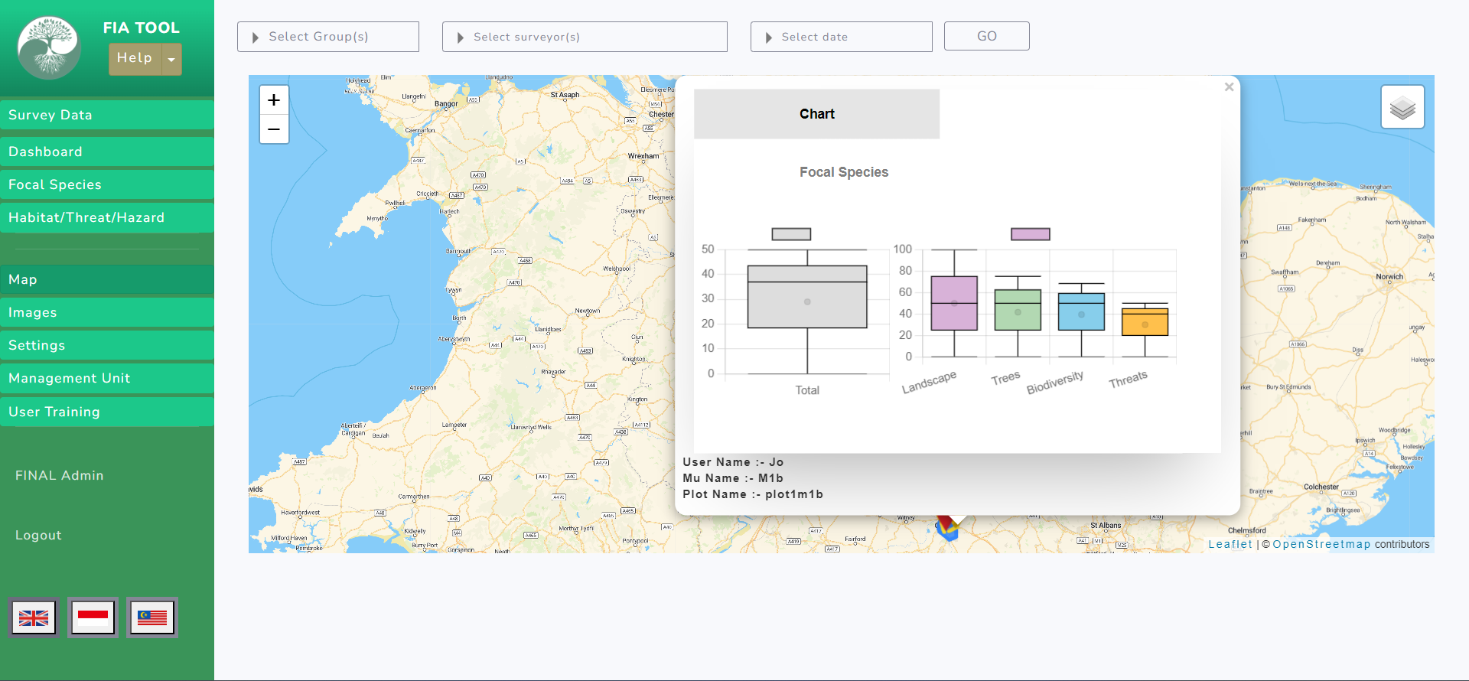

Figure 2: Showing records in chart when click on yellow marker.
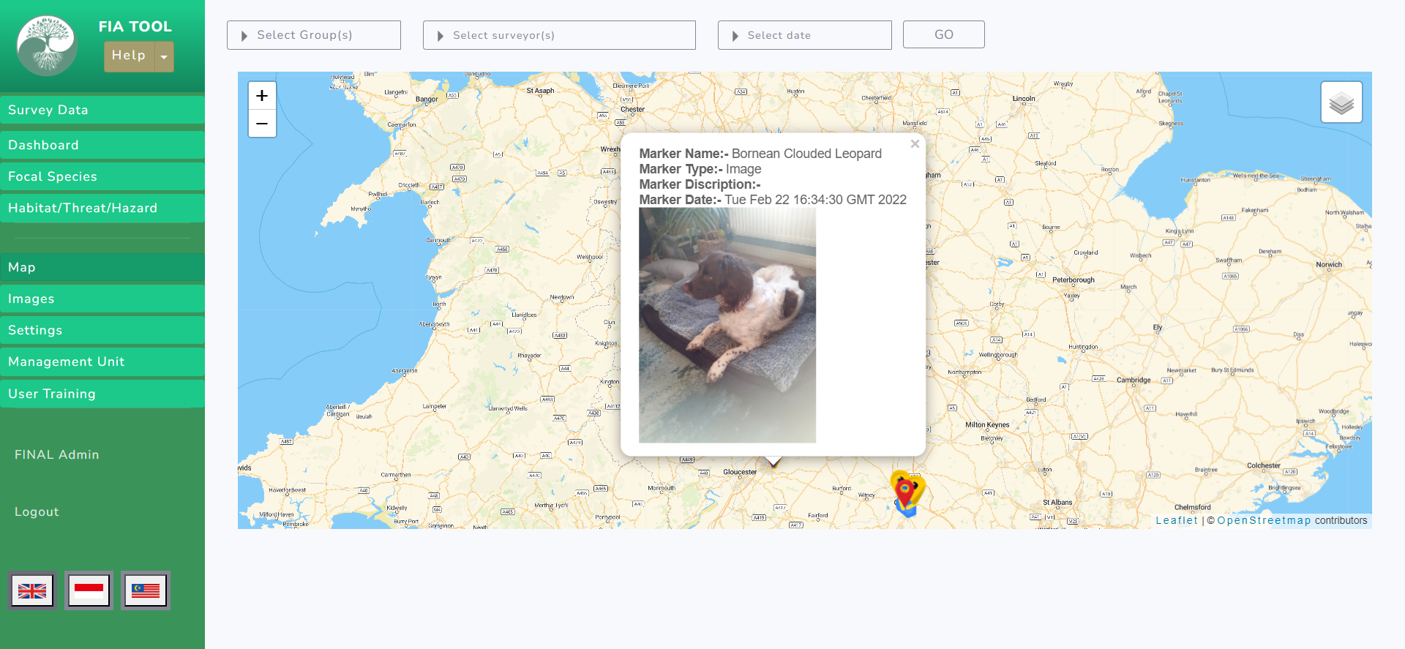

Figure 3: Showing focal species records in popup when click on blue marker.
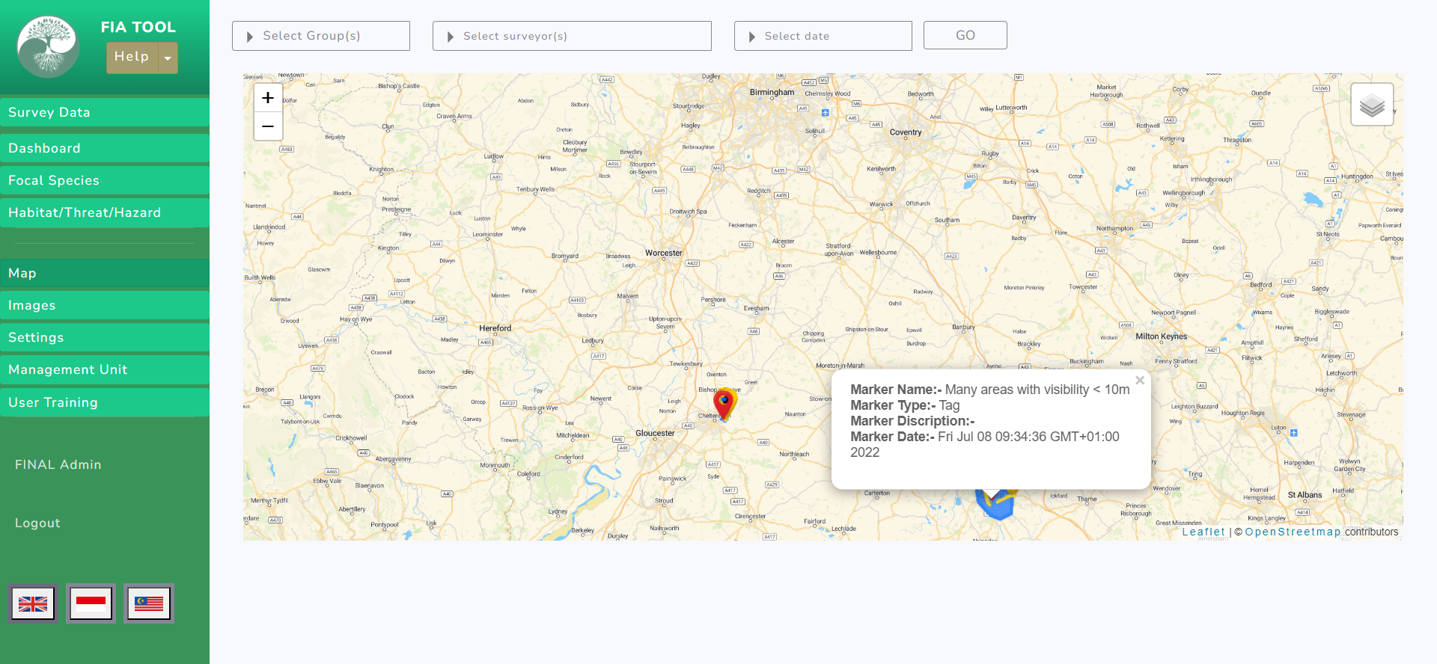

Figure 4: Showing focal species records of outside boundaries in popup when click on blue marker.

10. Image
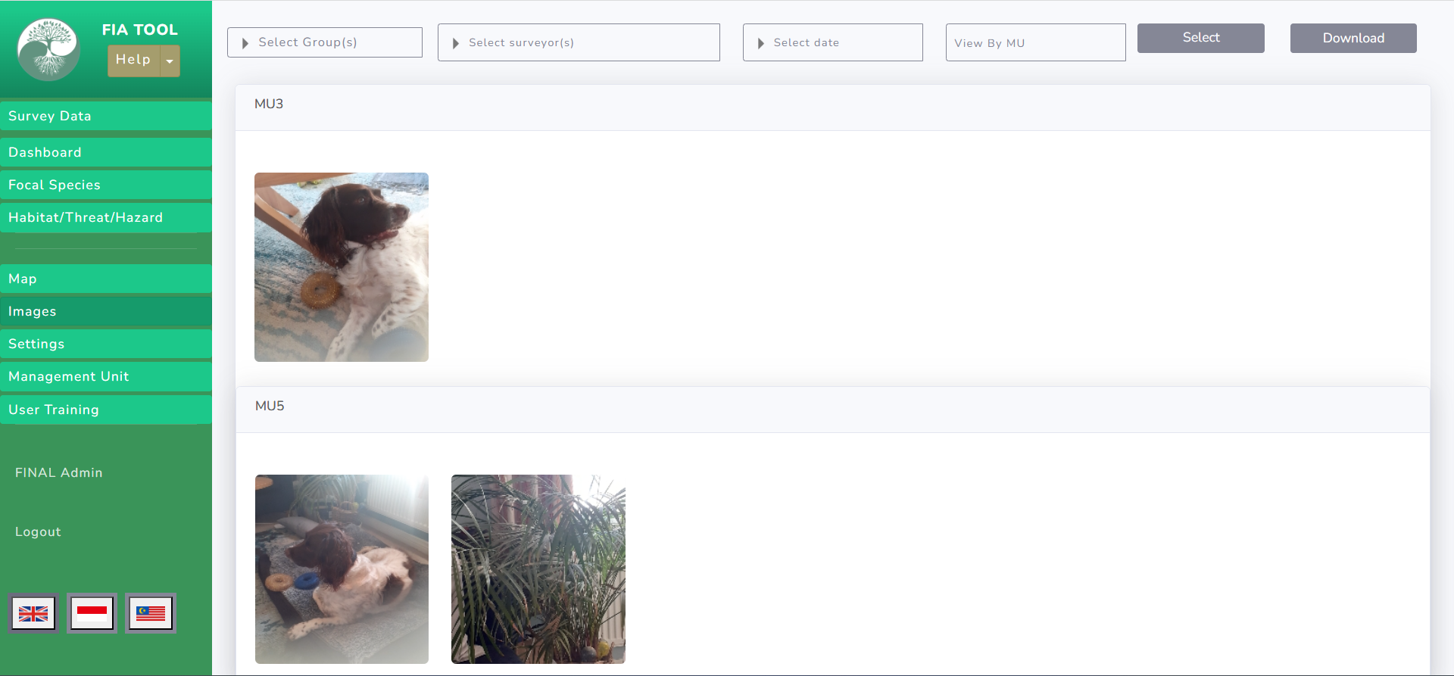

Figure 1: Showing Focal species and HTH Images of Selected Mus.
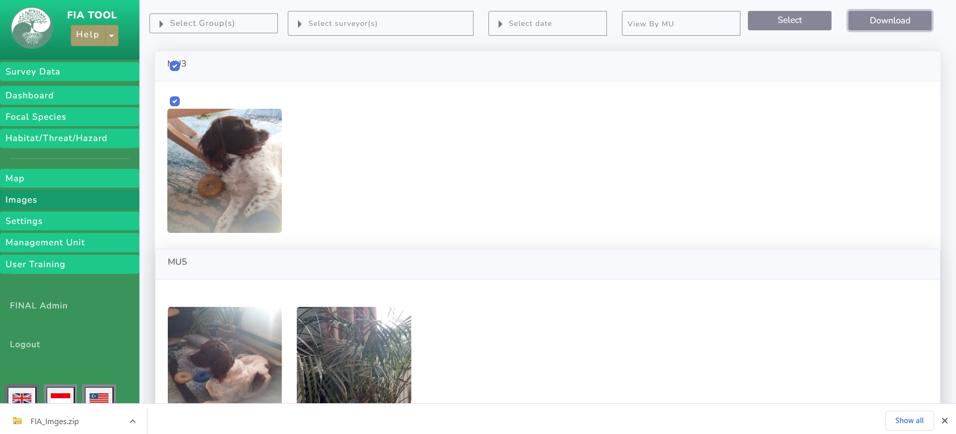

Figure 2: Showing selected images download files.
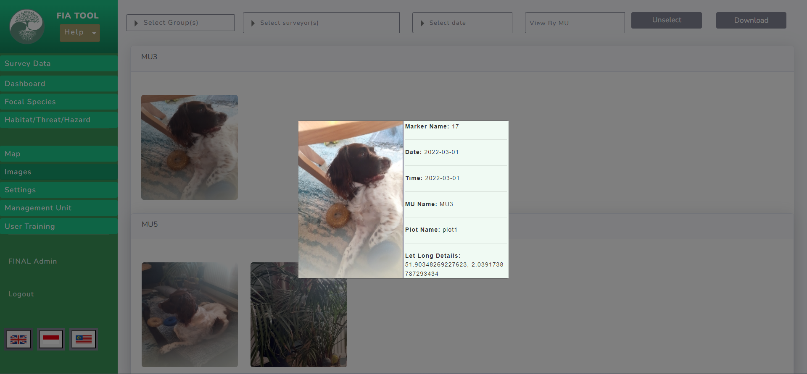

Figure 3: Showing Mu information’s when click on image after clicked on select/ unselect button.

11. Setting
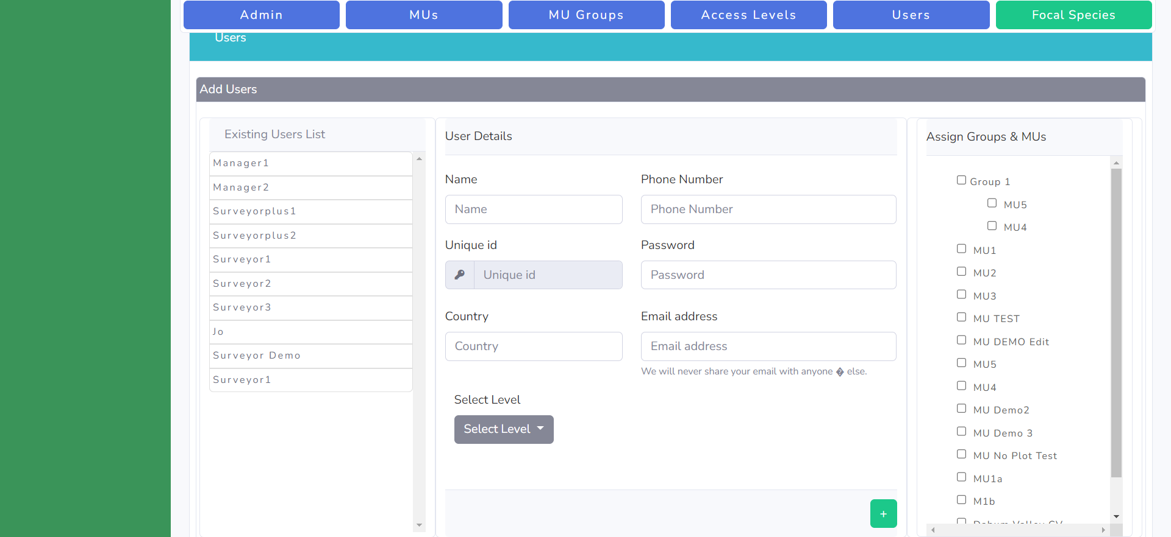

Figure 1: Showing Organization user list with mus.
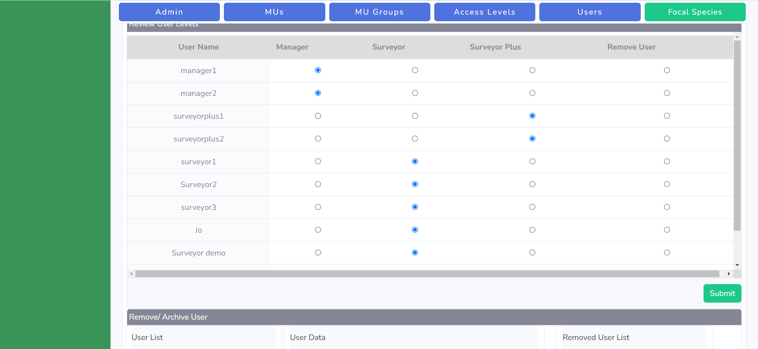

Figure 2: Showing Organization user level.

12. Focal Species Control
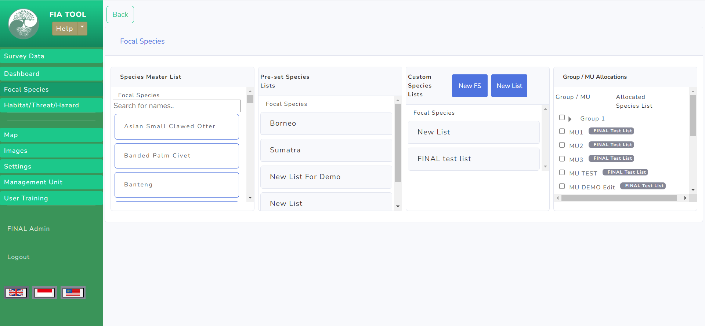

Figure 1: Showing Global and local focal species list and assigned focal species of the mus.

13. Management Unit
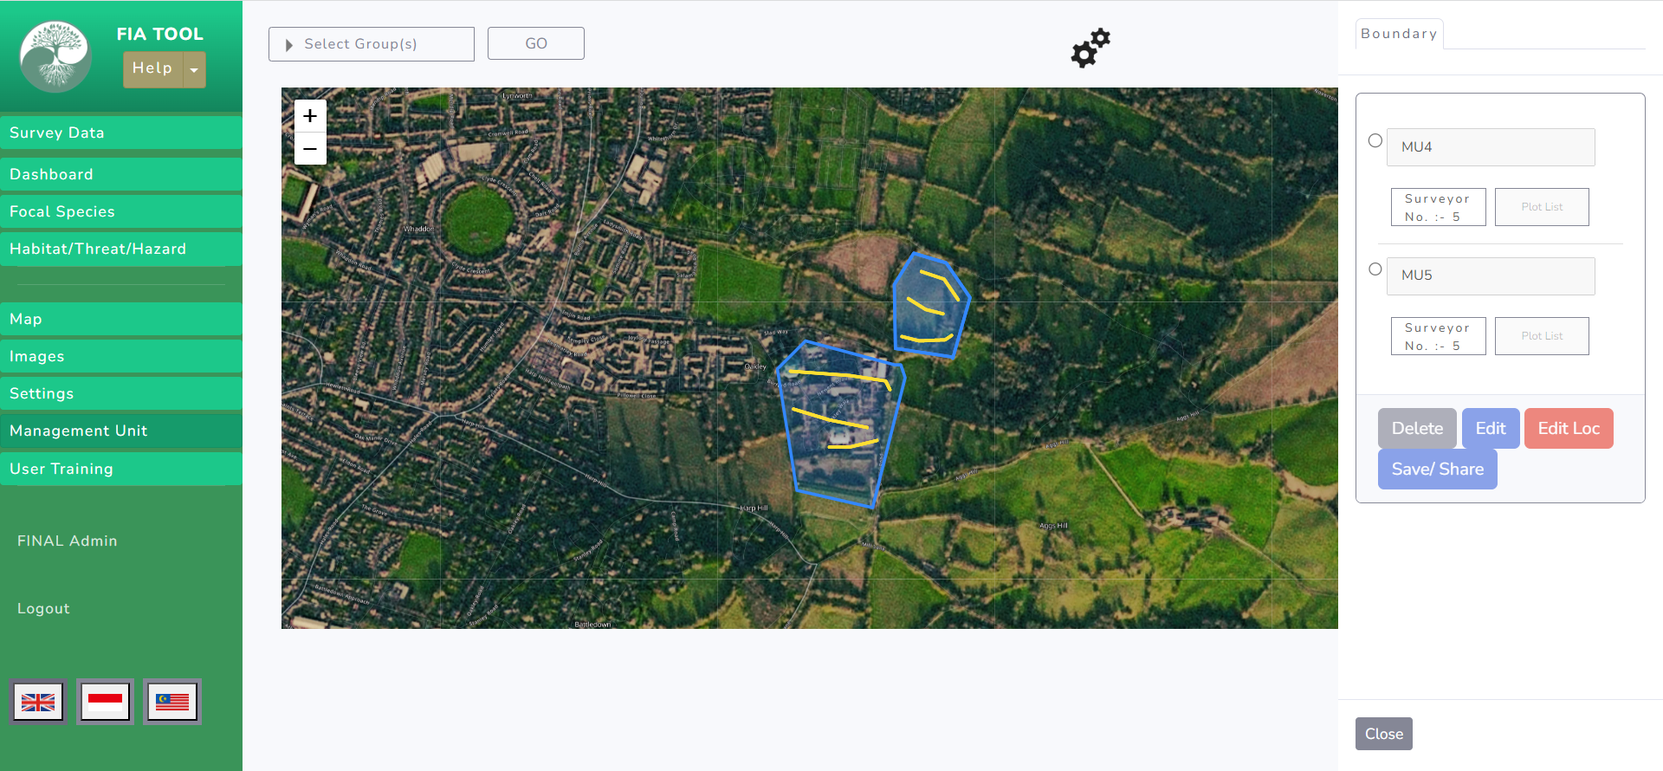

Figure 1: Showing selected mus boundaries and tracks on the map.
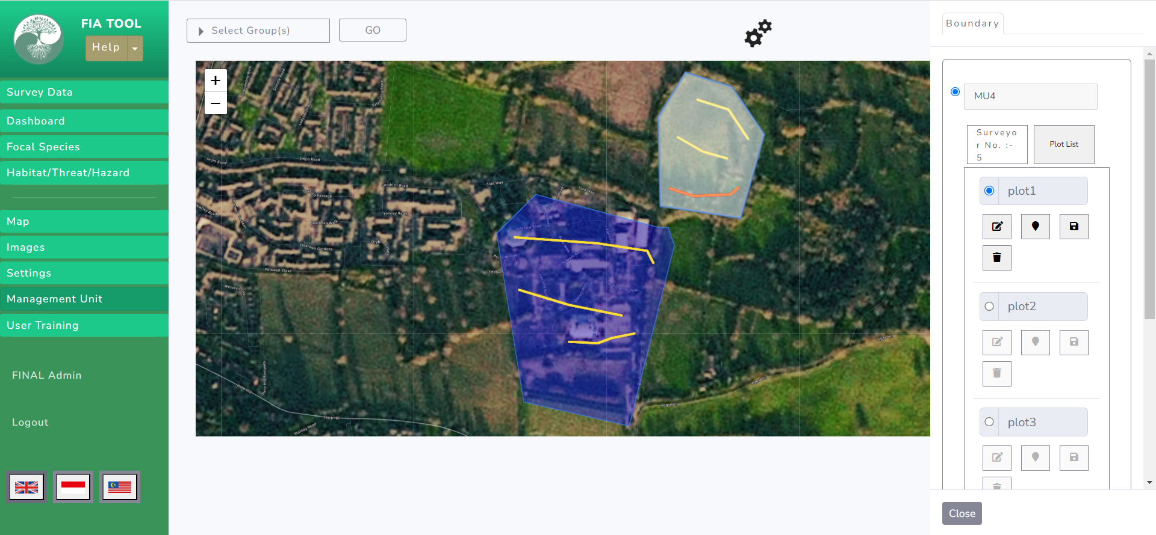

Figure 2: Highlighting boundaries and tracks on selection of mu and plot

14. User Training
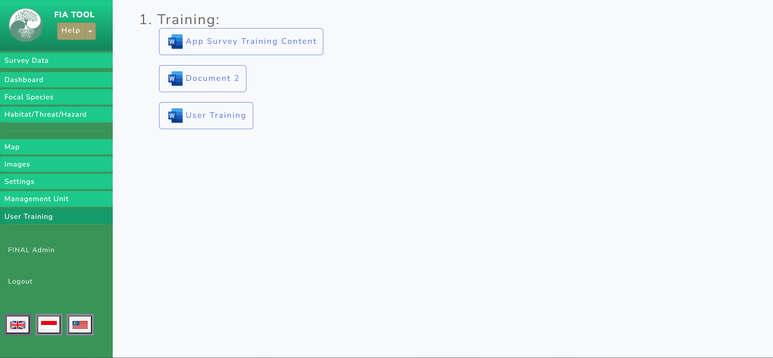

Figure 1: User training documents.
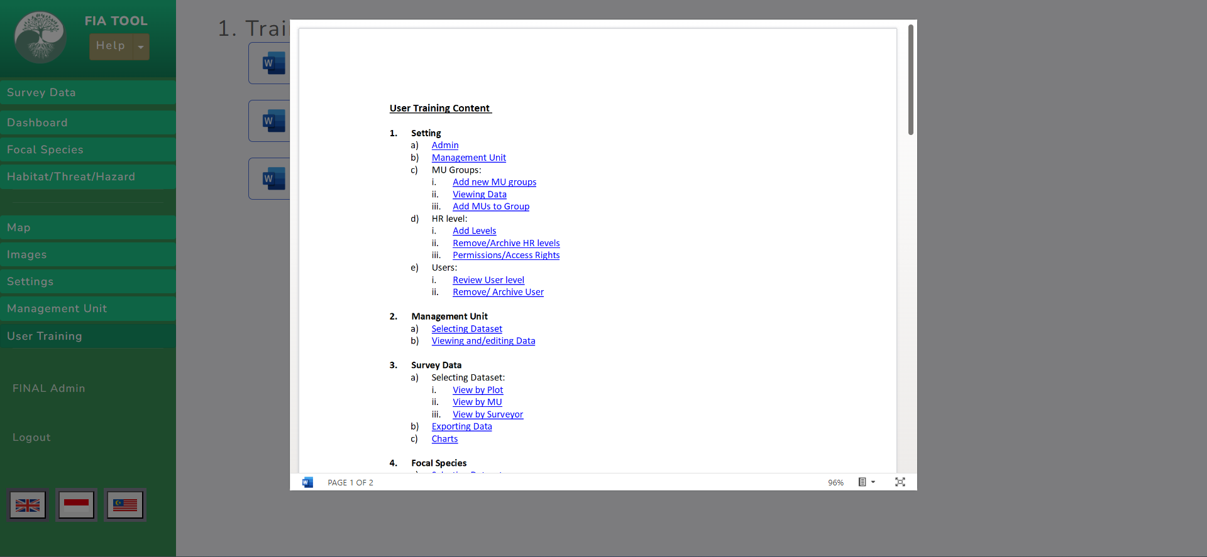

Figure 2: Sub-options of the training module.

